**Python and Bio-Python**

Assignment 9

**Programs demonstrating use of Randomization in Python**

1. Demonstrate mixing of lists elements and generate a funny story

Algorithm:-

Step 1:-Import the random function.

Step 2:-Create 2 lists ‘a’ and ‘b’.

Step 3:-We then use list indexing where the index value is randomly generated using the randint() function.

Step 4:- We then use the for loop to print multiple funny stories.

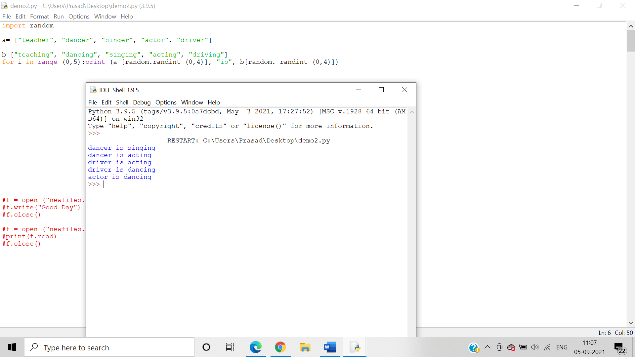

2. Write a program to create a “Guess the Number” game

Algorithm:-

Step 1:-Import the random function and use the randint() function to generate random numbers which are then assigned to the number variable.

Step 2:-Create multiple if else conditions where if the user input matches with the random number assigned to the number variable then the loop exits and the game is won.

Step 3:-In case the user input doesn’t match then if loop condition the code runs the next loop condition until the chances are exhausted.

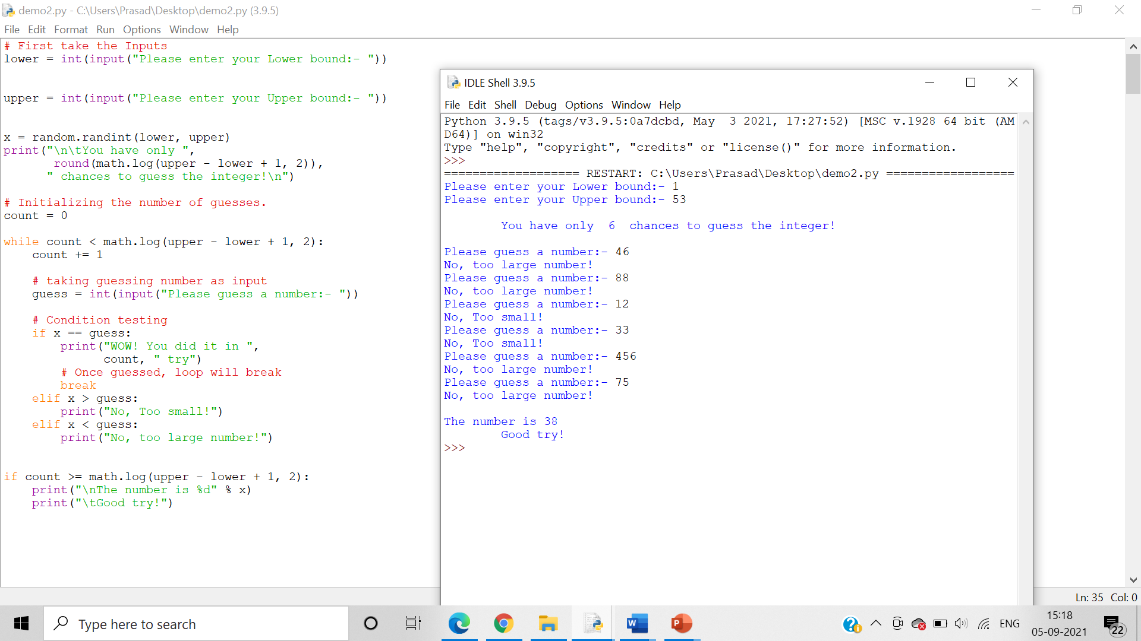

3. Write a program to perform insertion, substitution and deletion mutation in a user entered DNA string

Algorithm:-

Step 1:-User input is given for the type of function the user wants to perform.

Step 2:-Import the random function.

Step 3:-Create multiple if-else loops for the multiple functions.

Step 4:-we use the choice() and randint() function to perform insertion, substitution and deletion mutations randomly in a random position in the user given input sequence.

